**A Human-Centric Approach to Reducing Churn and Building Trust**

Submitted by: Ashutosh Sahoo

Date: 25th June 2025

1.Problem Statement

Insurance customers often experience significant frustration during the claims process due to poor communication, lack of transparency, and slow resolution times. Many users are left uncertain about what stage their claim is in, what documents are required, or how long it will take for them to receive a response or payout. This confusion and ambiguity not only create anxiety during already stressful moments (such as after accidents or health emergencies) but also lead to a breakdown in trust between the customer and the insurer.

This broken experience directly impacts key business metrics — **churn rates increase**, as customers are more likely to switch providers after a single bad claims experience. **Net Promoter Score (NPS)** also declines, as customers are less likely to recommend a company they feel was unresponsive or unclear when they needed help the most. In an industry where trust is a core value, an inefficient claims process can significantly hurt both brand loyalty and customer lifetime value.

To address this, we must rethink the claims experience from the customer’s point of view — focusing on **clarity, speed, and emotional reassurance**, especially during critical touchpoints.

1.1 User Journey Map 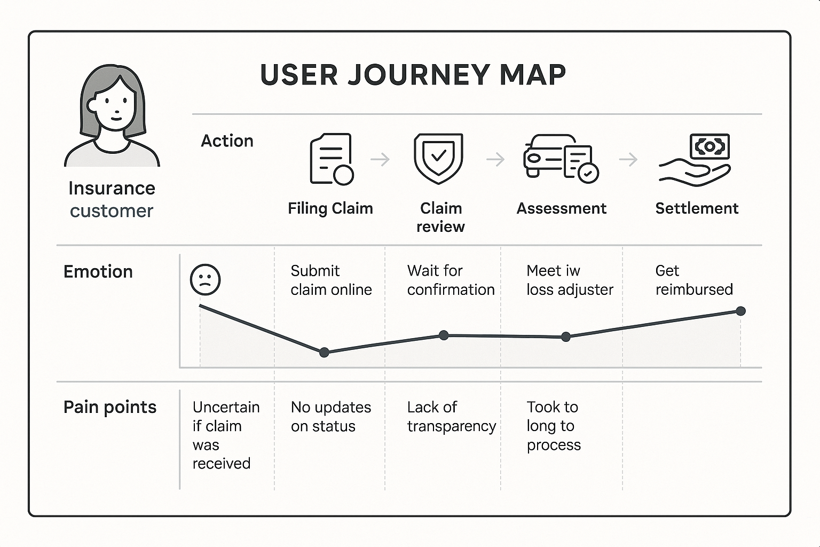

1.2 Pain Point Analysis 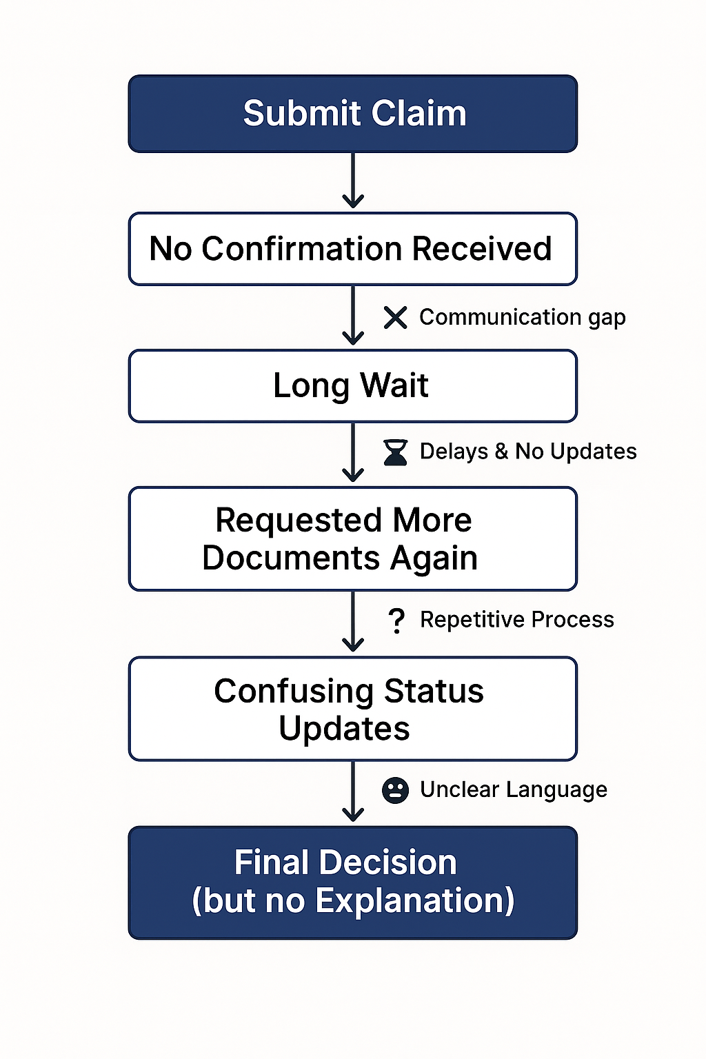

2.Proposed Solutions

#### 2.1. Transparency Improvements

* **Real-Time Claim Tracking Dashboard**: Introduce a user-accessible portal or mobile app feature that displays the live status of their claim (e.g., “Submitted → Under Review → In Progress → Resolved”). This helps customers stay informed and reduces uncertainty.
* **Document Status Updates**: Allow users to see which documents are accepted, pending, or flagged, along with specific reasons—minimizing guesswork and re-submissions.
* **Policy Interpretation Tool**: Implement a simple, interactive tool that explains complex policy terms and eligibility using everyday language and visuals.

#### 2.2 Speed Enhancements

* **Automated Initial Screening**: Use AI to perform preliminary checks (document verification, eligibility matching), reducing manual workload and speeding up the first review stage.
* **Priority Tagging for Critical Claims**: Claims flagged under emergency needs (like medical or travel-related) can be auto-tagged and routed for expedited processing.
* **Integrated Document Upload System**: Ensure the system accepts all major file types, prevents duplicates, and instantly confirms successful submission—streamlining the process.

#### 2.3 Communication Improvements

* **Proactive Notifications**: Send timely SMS/email/app notifications at every claim milestone (e.g., “Your claim is now under review”).
* **Dedicated Claim Support Chatbot**: Deploy a 24/7 virtual assistant to answer FAQs, guide users on next steps, and escalate queries when needed.
* **Single Point of Contact (SPOC)**: Assign one agent or representative per claim to avoid confusion and offer a more human, consistent support experience.

2.4 Wireframes or low-fidelity Prototype

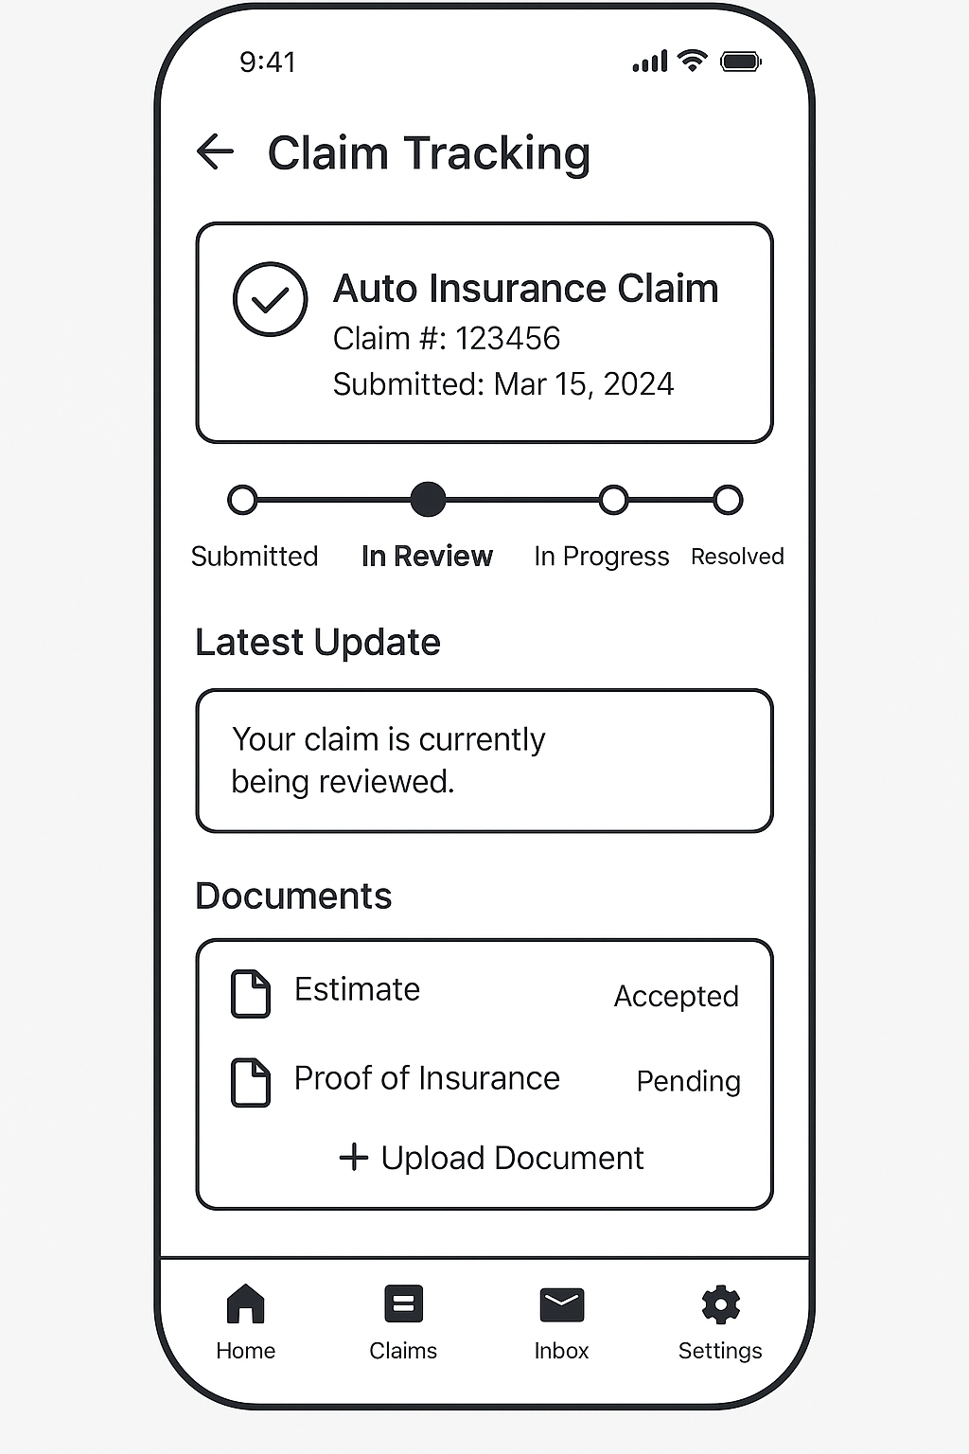

3.Lessons from My Churn Prediction Project

During my recent churn prediction project, I explored how customer behavior patterns can forecast their likelihood to leave a service. One important finding was that customers who made frequent support calls were more likely to churn—often due to unresolved issues or feeling unheard. This highlighted how gaps in communication and transparency can severely impact customer retention.

To build the prediction model, I applied algorithms like **Random Forest**, **Logistic Regression**, and **Gradient Boosting**, using data features such as usage behavior, plan details, and service interactions. The **Gradient Boosting model** outperformed others with an **F1-score of 0.8023** and **accuracy of 94.75%**, making it effective for identifying at-risk customers.

This same data-driven approach can improve the insurance claims experience. By tracking behavioral signals—like multiple follow-ups, delayed submissions, or complaints—insurers can create an early intervention system. For instance, a spike in support queries during the claim process could trigger proactive communication, clearer guidance, or faster resolution. This not only reduces customer frustration but also strengthens trust, ultimately minimizing the risk of churn.

4.Conclusion

The proposed redesign of the insurance claims experience directly addresses major user pain points such as lack of visibility, slow processing, and poor communication. By introducing features like a real-time claim tracking dashboard, proactive status updates, and priority-based automation, the solution enhances both transparency and efficiency. These changes aim to reduce customer frustration, increase trust, and improve overall satisfaction, which can positively influence retention and Net Promoter Score (NPS).

This approach reflects a strong combination of product thinking and data science application. By deeply understanding the user's journey and aligning product features to their core needs, the solution demonstrates empathy-driven design. Simultaneously, the integration of data-backed insights—such as churn factors and operational inefficiencies—shows the value of analytics in shaping impactful product decisions. This balance ensures that the redesign is not only user-friendly but also strategically aligned with business goals.